Monica Lallo, Ed.D., MPM, MPA
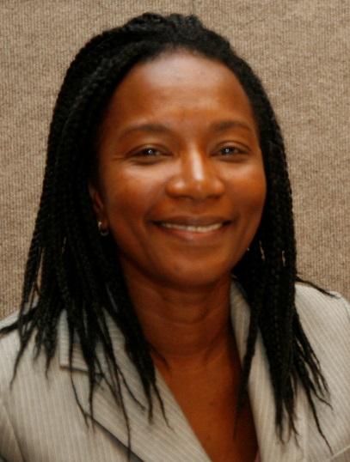
PHOTO

Dr. Monica Lallo is an educator, team strategist and advocate for improving government and nonprofit services to underserved youth and families. Throughout her professional career, she has been committed to bridging the socioeconomic divide that exists in disadvantaged communities. She has been actively involved in government-funded youth improvement initiatives and her work has heightened capacity building efforts for nonprofit organizations, both domestically and internationally.
Dr. Lallo received her Doctorate in Education from Immaculata University, her Master’s degree in Public Administration from New York University. and Bachelor’s degree in Psychology and Criminal Justice from Rutgers University. She taught several courses at Rowan College at Burlington County (RCBC) in the Human Services Program as a Senior Adjunct Professor. She has been a training consultant for LISC and keynote speaker at East Stroudsburg University, Sociology and Criminal Justice Departments.
Dr. Lallo has extensive experience specializing in contract management, program development and evaluation over the eleven years in county government. She produced several accomplishments with the creation of numerous initiatives that helped improve service delivery outcomes, increase stakeholder involvement and promote networking among nonprofit organizations serving youth and families in the County of Union. Dr. Lallo also served as a resource to local agency providers seeking state and national research information about services rated effective by the Federal Office of Juvenile Justice and Delinquency Prevention and other national foundations that support youth initiatives. Her philanthropic endeavors and longstanding commitment in the area of youth development is consistent with her belief:
“To whom much is given, much is required. Therefore, as a professional, I am dedicated to serving communities, while working with others to find ongoing solutions to socioeconomic problems affecting today’s youth and families.”
Dr. Lallo plans to utilize her skills and professional experience to assist organizations in their continued efforts to serve children and families within the United States and globally through Global Highpoint Management and Training Consulting Service, LLC.

