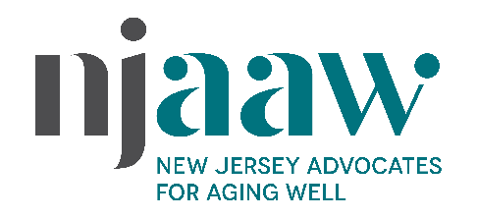
145 West Hanover Street, Trenton, NJ 08618
609•421•0206 njaaw.org sbrooks@njaaw.org

Formerly NJ Foundation for Aging

CONTACT: Sue Brooks, 609-421-0206

Bio of Cathy Rowe, DrPH, Executive Director

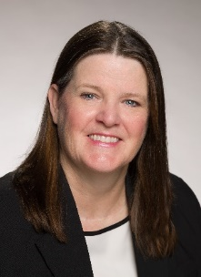
Cathy Rowe, DrPH, was appointed Executive Director of New Jersey Advocates for Aging Well (NJAAW), a leader in optimizing the aging experience for New Jersey residents since 1998, on May 3, 2021.
Most recently, Dr. Rowe served as Coordinator for SOMA (South Orange/Maplewood): Two Towns for All Ages, a grant-funded healthy aging initiative in a community with more than 6,000 residents over 60. This cutting-edge collaboration, based on the World Health Organization’s Domains of Healthy Aging, focuses on developing programs to address economic and infrastructure needs for an age-friendly community.
Dr. Rowe has spoken extensively on aging issues at conferences and symposia. In 2020, the National Association of Area Agencies on Aging presented her with a “Best Practices for Socially Engaging Older Adults Award” for the “Repair Café” she established – the first of its kind in NJ. An inter-generational event, the cafe brings together people of all ages and levels of expertise to repair and save treasured items. Dr. Rowe earned her DrPH in Health Policy and Management from Columbia University, where she received a Fellowship in Public Policy. Her BA in Economics is from Bates College.
Dr. Rowe can be reached at crowe@njaaw.org.
# # #
NJ Advocates for Aging Well (NJAAW, njaaw.org), formerly NJ Foundation for Aging, has been at the forefront of revolutionizing the aging experience since 1998. It is the only statewide nonprofit focused solely on providing leadership in public policy and education to enable older adults to live with independence and dignity in their communities. NJAAW’s social action issues include senior housing and hunger, elder economic security, older workers and transportation. The award-winning Aging Insights, a monthly topical TV program produced by NJAAW, connects caregivers, seniors and their families to community-based services and resources. The show is available on NJAAW’s YouTube channel at youtube.com/c/njadvocatesforagingwell, at njaaw.org and more than 70 public-access stations across NJ (check local listings for channels and times). NJAAW also presents educational forums and an Annual Conference offering development opportunities and best practices for professionals entrusted with caring for older adults. “Rebounding and Rebuilding,” the 23rd conference, takes place online June 3 and 4, 2021.

