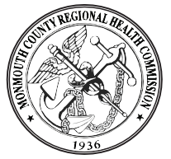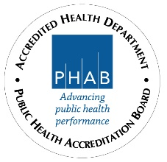

MONMOUTH COUNTY REGIONAL HEALTH COMMISSION NO. 1
1540 WEST PARK AVE., STE 1 OCEAN TWP., NJ 07712
Tel 732-493-9520 Fax 732-493-9521
www.mcrhc.org

Health Officer – F/T Health Department Salary Commensurate with experience
The Monmouth County Regional Health Commission No. 1 is seeking a full-time Health Officer to oversee the personnel, operations and budgets of all health services; communicable disease, childhood and adult immunization program; health education; epidemiology; environmental and food establishment inspections; animal control, and social services. The Health Officer is responsible for planning, designing, prioritizing, and scheduling their own work, including in the field inspections and the work of health department employees. Duties include but are not limited to planning and establishing Health Department programs and services; reviewing all Department activities; ensuring compliance with public health statutes and regulations; issuing permits; performing complex professional and administrative work and other duties as required. Full job description can be found on our website at mcrhc.org under employment.
Candidate must have a current Health Officer License issued by the New Jersey Department of Health and driver’s license. Pre-employment drug screen and background checks are performed. The Monmouth County Regional Health Commission is an EEO employer and reserves the right to interview qualified candidates prior to the deadline. Pension and benefit package offered along with vacation, sick and holiday pay. If further details of the position are needed, please contact us at Info@mcrhc.org. Interested candidates should submit a cover letter with subject line “Health Officer” and include salary requirements, resume and references via email to info@Mcrhc.org or by regular mail at 1540 West Park Ave., Suite 1 Ocean Twp., NJ 07712 by January 31, 2023

